VISVESVARAYA TECHNOLOGICAL UNIVERSITY

Jnana Sangama, Belgaum -590014, Karnataka State, India

A PROJECT REPORT ON
“G-care: An AI Healthcare Assistant”
BACHELOR OF ENGINEERING
IN
DEPARTMENT
OF
COMPUTER SCIENCE ENGINERRING [AI&ML]

Submitted by: -

Yeshrutha S | 1EW23CI063
Abhay Vadagi | 1EW23CI002



EAST WEST INSTITUTE OF TECHNOLOGY
Off Magadi Main Road, Bengaluru, Karnataka — 560 091
AY 2026-27

CERTIFICATE

This is to certify that the project report entitled G-care: An AI Healthcare Assistant submitted by Yeshrutha S and Abhay Vadagi bearing the USN 1EW23CI063 and 1EW23CI002 to the Visvesvaraya Technological University, Belagavi, in partial fulfillment for the award of the degree of B. Tech in CSE[AI&ML] is a bona fide record of project work carried out by her under my supervision. The contents of this report, in full or in parts, have not been submitted to any other Institution or University for the award of any degree.

Signature:
Name of the Guide: Asst. Prof. Sreehari M
Department: CSE[AI&ML]

Signature of HOD with seal

DECLARATION

I/We declare that this project report titled G-care: An AI Healthcare Assistant submitted in partial fulfillment of the degree of B. Tech in CSE[AI&ML] is a record of original work carried out by me under the supervision of Sreehari M, Assitant Professor, CSE[AI&ML], and has not formed the basis for the award of any other degree, in this or any other Institution or University. In keeping with the ethical practice in reporting scientific information, due acknowledgements have been made wherever the findings of others have been cited.

Signature of the student(s)
Name Signature
1. Yeshrutha S
2. Abhay Vadagi

EAST WEST INSTITUTE OF TECHNOLOGY
Off Magadi Main Road, Bengaluru, Karnataka — 560 091
Department of CSE[AI&ML]
CERTIFICATE
Certified that the project work entitled G-care: An AI Healthcare Assistant was carried out by Mr./Ms. Yeshrutha S and Abhay Vadagi, USN 1EW23CI063 and 1EW23CI063, a bonafide student of Asst. Prof. Sreehari M in partial fulfilment for the award of Bachelor of Engineering / Bachelor of Technology in CSE[AI&ML] of the Visveswaraiah Technological University, Belgaum during the year 2026-27. It is certified that all corrections/suggestions indicated for the Internal Assessment have been incorporated in the Report deposited in the departmental library. The project report has been approved as it satisfies the academic requirements in respect of Project work prescribed for the said Degree.

Name & Signature of the Guide | Name Signature of the HOD | Signature of the Principal

External Viva
Sl. No. Name of the examiners Signature with date
1
2

ABSTRACT

With the rising global geriatric population and the prevalence of nuclear family structures, ensuring the continuous health monitoring, safety, and independence of senior citizens has emerged as a critical societal and technological challenge. Elderly individuals living independently frequently face life-threatening risks due to unmonitored chronic conditions, missed medication schedules, undetected physical falls, and delayed emergency responses. Existing remote healthcare systems often suffer from high operational costs, steep learning curves, fragmented communication, and interfaces unsuitable for seniors.
To resolve these limitations, this project presents G-Care (Guardian Care), an integrated, full-stack, and intelligent remote elderly care platform that bridges the communication gap between elderly patients, family guardians, and healthcare practitioners. The system incorporates a tri-tier, Role-Based Access Control (RBAC) architecture featuring a Senior Wearable Interface / Simulator, a Caretaker & Guardian Dashboard, and a Specialized Clinical Doctor Portal. Real-time physiological telemetry—including heart rate, peripheral oxygen saturation (${\text{SpO}}_{2}$), blood pressure, body temperature, stress, and hydration—is monitored continuously and processed through real-time anomaly detection heuristics to immediately identify critical vitals deviations, physical falls, and geofence breaches.
The platform provides an automated medication and routine scheduling engine with interactive adherence check-offs, instant SOS emergency dispatch protocols, and senior-centric accessibility features including a multilingual voice assistant supporting regional Indian languages (English, Hindi, Kannada, and Tamil). Developed using React 18, TypeScript, Tailwind CSS, Zustand, and Node.js/Express with PostgreSQL and JWT authentication, G-Care provides a scalable, secure, and cost-effective solution for proactive geriatric telecare. Experimental evaluations demonstrate responsive vitals synchronization, low alert dispatch latency, and significant reduction in caregiver dependency.
Keywords: Elderly Care Monitoring, Telehealth, Internet of Medical Things (IoMT), Vitals Anomaly Detection, Role-Based Access Control, Medication Adherence, Fall Detection, Multilingual Voice Assistant.

ACKNOWLEDGEMENT

With Great pride we would like to convey our gratitude and appreciation to our alma-mater “East West Institute of Technology” for giving us the required platform for the fulfillment of the Project on “G-care: An AI Healthcare Assistant” as per the V.T.U requirements, for the major Project.

We express our sincere thanks to Dr. Nagaraj G Cholli, Principal of East West Institute of Technology, for providing us with excellent infrastructure to complete the Project.

We express wholehearted gratitude to Dr. Venkatesha G who is the respectable HOD of the Department of CSE[AI&ML] and CSE[IoT, CyS and BCT]. We wish to acknowledge her help in making my task easy by providing us with his valuable help and encouragement.

It is our pleasure to thank my guide Assistant Prof. Sreehari M and the project co-ordinator
Prof. Shubha C, EWIT for their guidance, encouragement and valuable suggestion from the beginning of the Project till the completion without which would not have been accomplished. We are greatly indebted to them.

And last but not the least, we would be very pleased to express our heartful thanks to the teaching and non-teaching staff of the Department CSE[AI&ML], EWIT for their motivation and support. We also thank all those who extended their support and co-operation while bringing out this internship.

YESHRUTHA S | 1EW23CI063
ABHAY VADAGI | 1EW23CI002

LIST OF FIGURES

Figure No | Name | Page No
1.1 | High-Level Conceptual Architecture and Dataflow of the G-Care Ecosystem | 5
3.1 | Multi-Tier Layered System Architecture of G-Care | 11
3.2 | DFD Level 0 — Context Level Diagram | 14
3.3 | DFD Level 1 — Detailed Functional Data Flow Diagram | 15
5.1 | End-to-End Operational Methodology Flowchart of G-Care | 23
5.2 | Shared I2C Bus Interfacing on Prototype Breadboard | 25
5.3 | Entity-Relationship Diagram of G-Care Platform | 26
5.4 | Use Case Diagram for the Tri-Tier G-Care System | 27
7.1 | Multi-Tier Testing Pipeline for G-Care Platform | 38

LIST OF TABLES

Table No | Name | Page No
2.1 | Comparison Matrix of State-of-the-Art Solutions vs. Proposed G-Care Platform | 8
4.1 | Edge Hardware and Prototyping Components | 16
4.2 | Software Technology Stack | 18
6.1 | Breadboard Pin Interfacing and Wiring Connections | 28
7.1 | Comprehensive System Test Cases and Empirical Verification Results | 39

CONTENTS

Chapter No. | Chapter Name | Page No.
CHAPTER 1 | INTRODUCTION | 1
 | 1.1 | 2
 | 1.2 | 3
CHAPTER 2 | LITERATURE REVIEW | 6
 | 2.1 | 6
 | 2.2 | 8
 | 2.3 | 9
CHAPTER 3 | SYSTEM ARCHITECTURE | 11
 | 3.1 | 11
 | 3.2 | 12
 | 3.3 | 14
CHAPTER 4 | SYSTEM REQUREMENTS | 16
 | 4.1 | 16
 | 4.2 | 18
 | 4.3 | 20
CHAPTER 5 | METHODOLOGY | 22
 | 5.1 | 22
 | 5.2 | 24
CHAPTER 6 | IMPLEMENTATION | 28
 | 6.1 | 28
 | 6.2 | 32
 | 6.3 | 36
CHAPTER 7 | TESTING | 38
 | 7.1 | 38
 | 7.2 | 39
CHAPTER 8 | CONCLUSION AND FUTURE SCOPE | 42
 | BIBILIOGRAPY | 45
 | APPENDIX I | 46

BIBLIOGRAPHY

[1] S. M. R. Islam, D. Kwak, M. H. Kabir, M. Hossain, and K.-S. Kwak, "The Internet of Things for Health Care: A Comprehensive Survey," IEEE Access, vol. 3, pp. 678–708, 2015, doi: 10.1109/ACCESS.2015.2437951.
[2] S. Majumder, T. Mondal, and M. J. Deen, "Wearable Sensors for Remote Health Monitoring," Sensors, vol. 17, no. 1, Art. no. 130, 2017, doi: 10.3390/s17010130.
[3] J. Allen, "Photoplethysmography and its application in clinical physiological measurement," Physiological Measurement, vol. 28, no. 3, pp. R1–R39, 2007, doi: 10.1088/0967-3334/28/3/R01.
[4] R. Igual, C. Medrano, and I. Plaza, "Challenges, Issues and Trends in Fall Detection Systems," BioMedical Engineering OnLine, vol. 12, Art. no. 66, 2013, doi: 10.1186/1475-925X-12-66.
[5] N. K. Choudhry et al., "Effect of Reminder Devices on Medication Adherence: The REMIND Randomized Clinical Trial," JAMA Internal Medicine, vol. 177, no. 5, pp. 624–631, 2017, doi: 10.1001/jamainternmed.2016.9627.
[6] P. Nallam, S. Bhandari, J. Sanders, and A. Martin-Hammond, "Exploring the Perceived Benefits and Barriers of Intelligent Voice Assistants for Older Adults," Gerontology and Geriatric Medicine, vol. 6, pp. 1–13, 2020, doi: 10.1177/2333721420985975.
[7] Espressif Systems, "ESP32-S3 Wireless Microcontroller & MAX30102 Biosensor Hardware Integration Datasheets," Maxim Integrated / Espressif Co., Ltd., 2023.

APPENDIX A

SNAPSHOTS

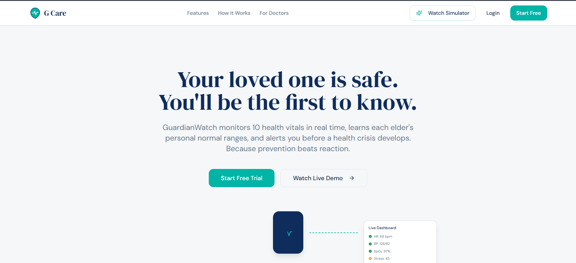
G Care Telecare Platform

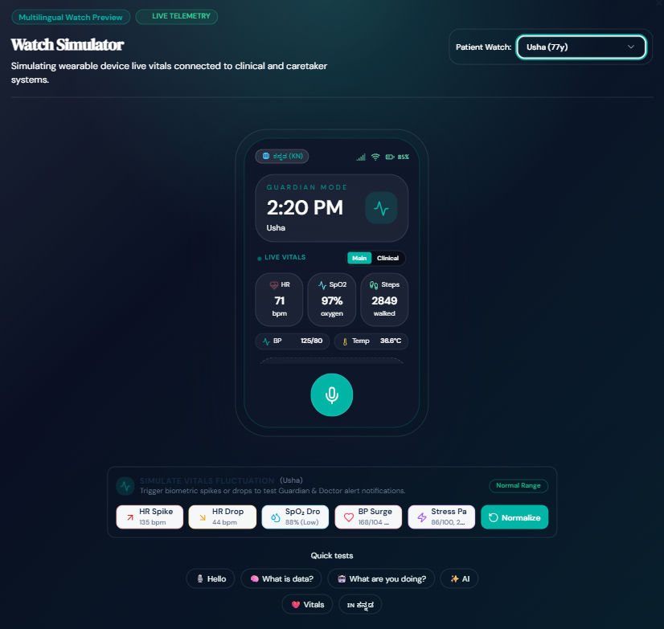
G-Care Multilingual Watch Simulator Interface
Page 46
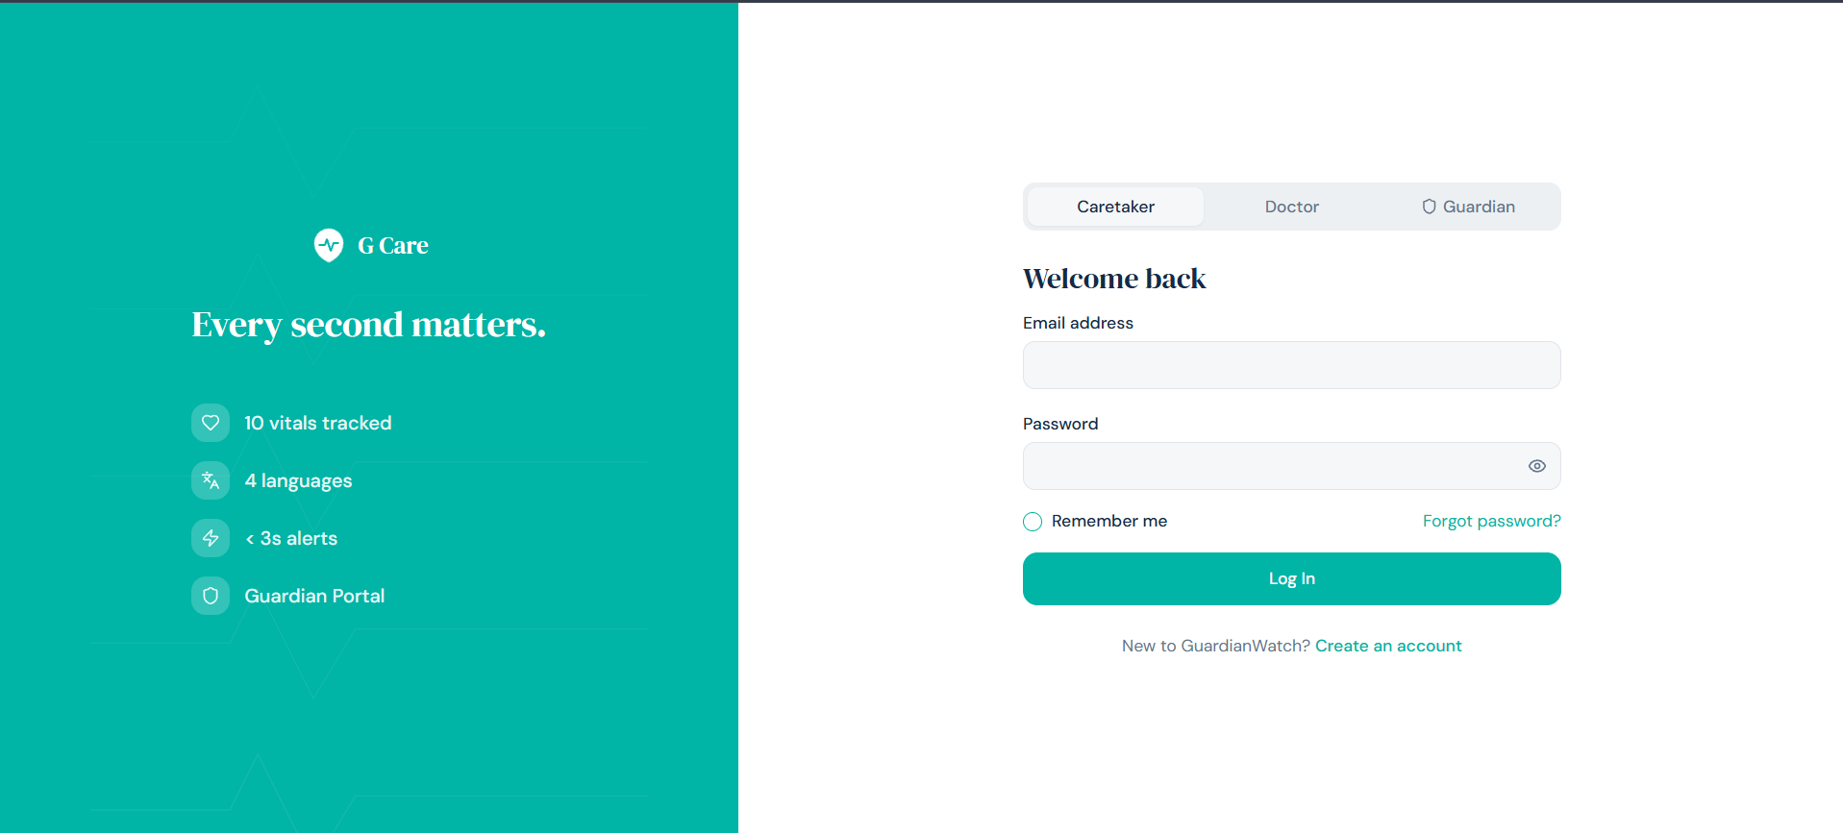
Multi-Role User Authentication and Login Interface

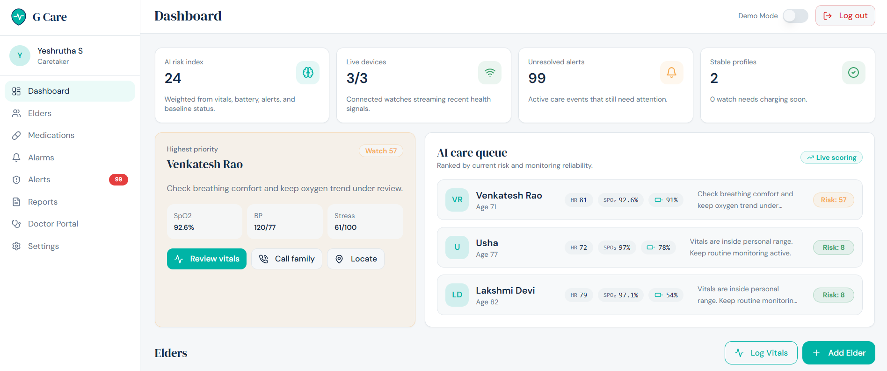
Caretaker Dashboard for Elder Health Monitoring

Page 47

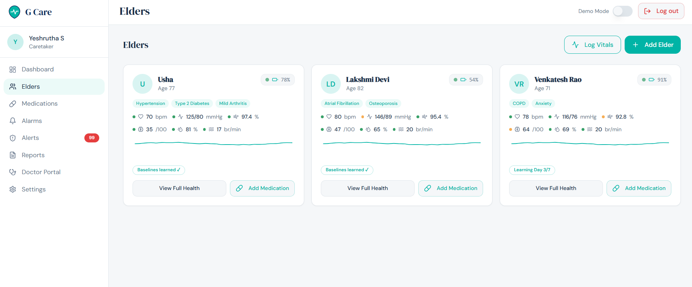
Caretaker Elders Health Monitoring Dashboard

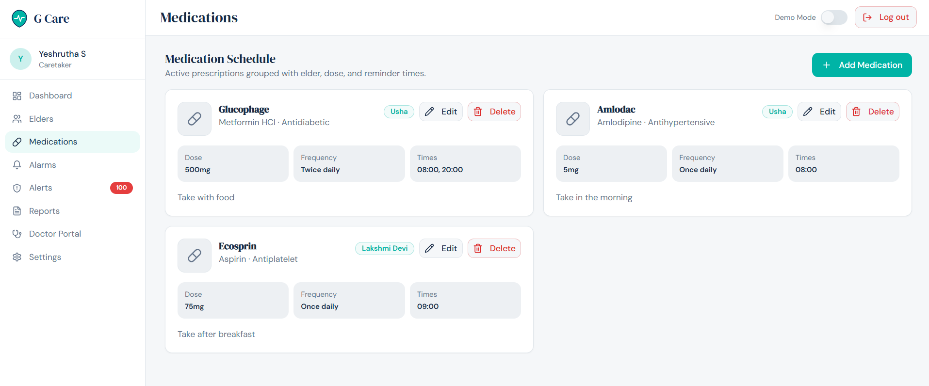
Caretaker Medication Schedule and Management Interface

Page 48

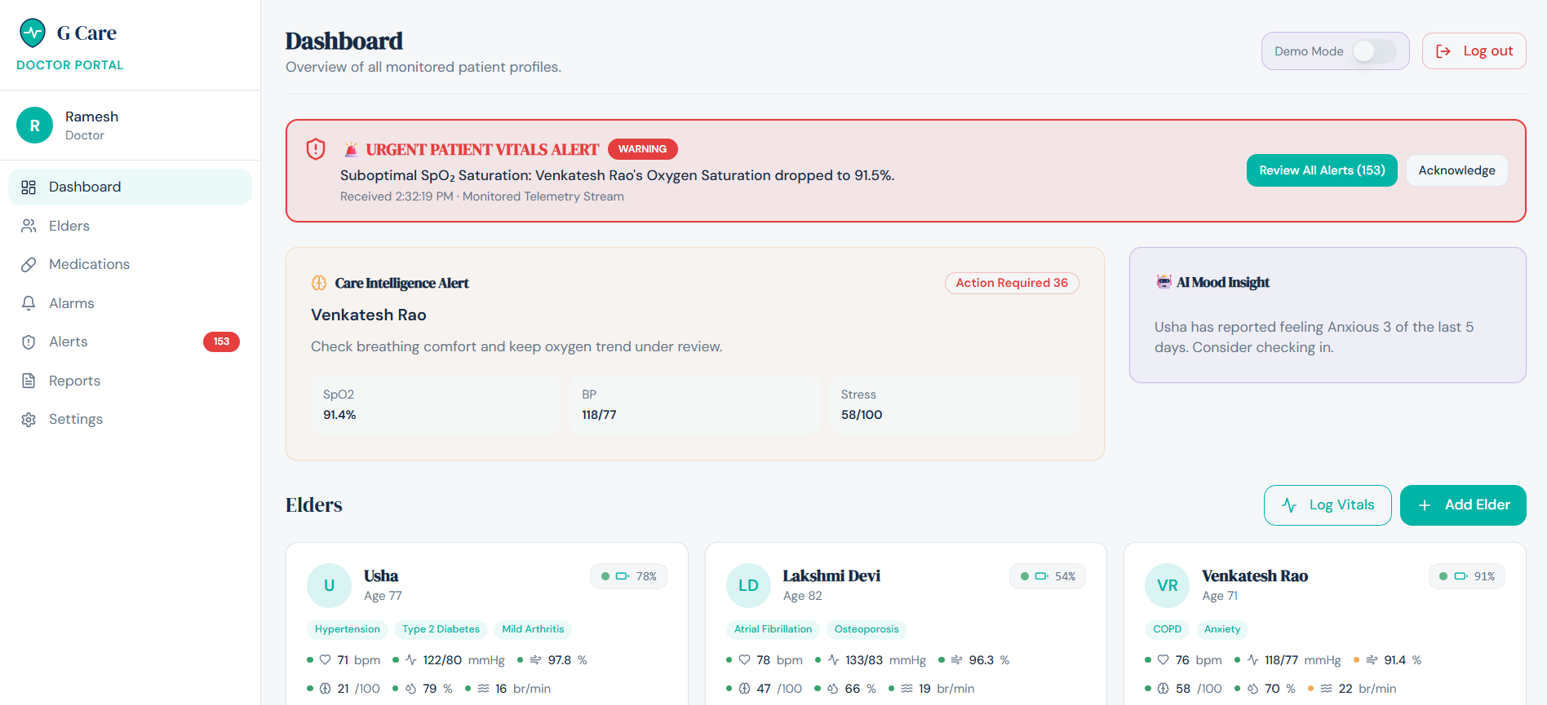
Doctor Portal Dashboard for Patient Monitoring and Clinical Alerts

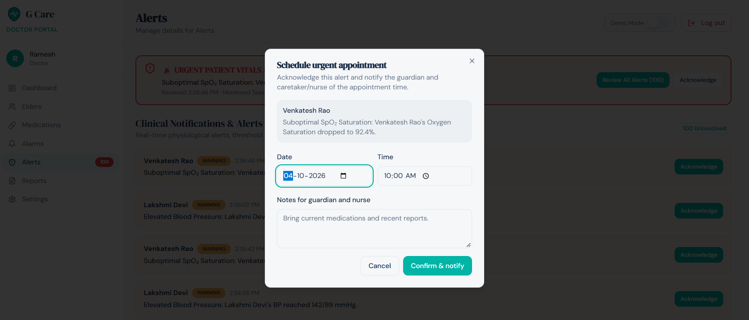
Clinical Alert Management and Urgent Appointment Scheduling

Page 49

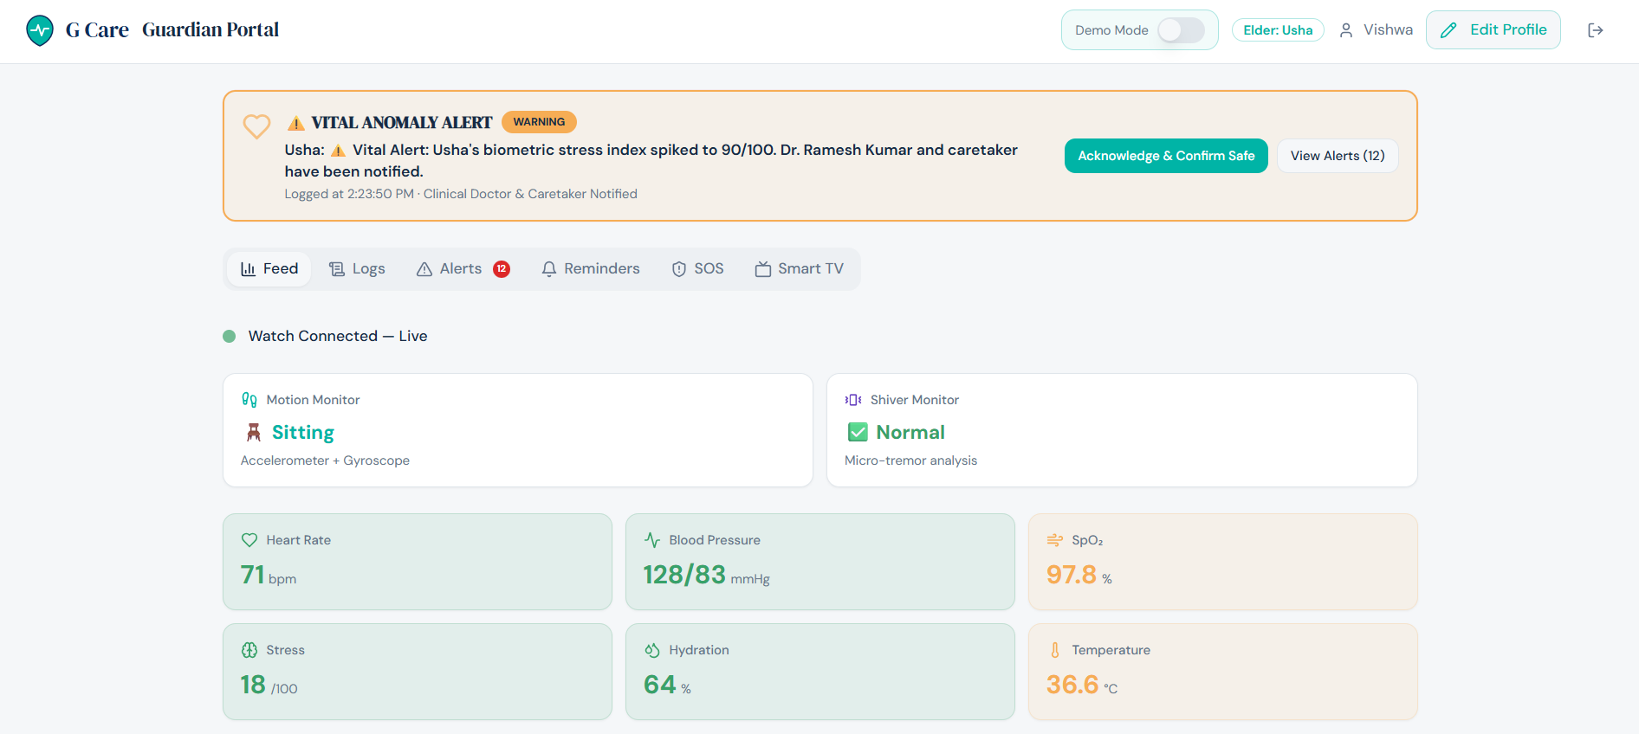
Guardian Portal for Real-Time Elder Health Monitoring

Page 50

